**Agenda**

* Version Control – What and Why?
* Version controls tools
* GitHub and Git
* Case study: Dominion Enterprises
* Git Features
* Git Operations and commands

<https://www.youtube.com/watch?v=xuB1Id2Wxak&t=4140s>

**Version Control System**

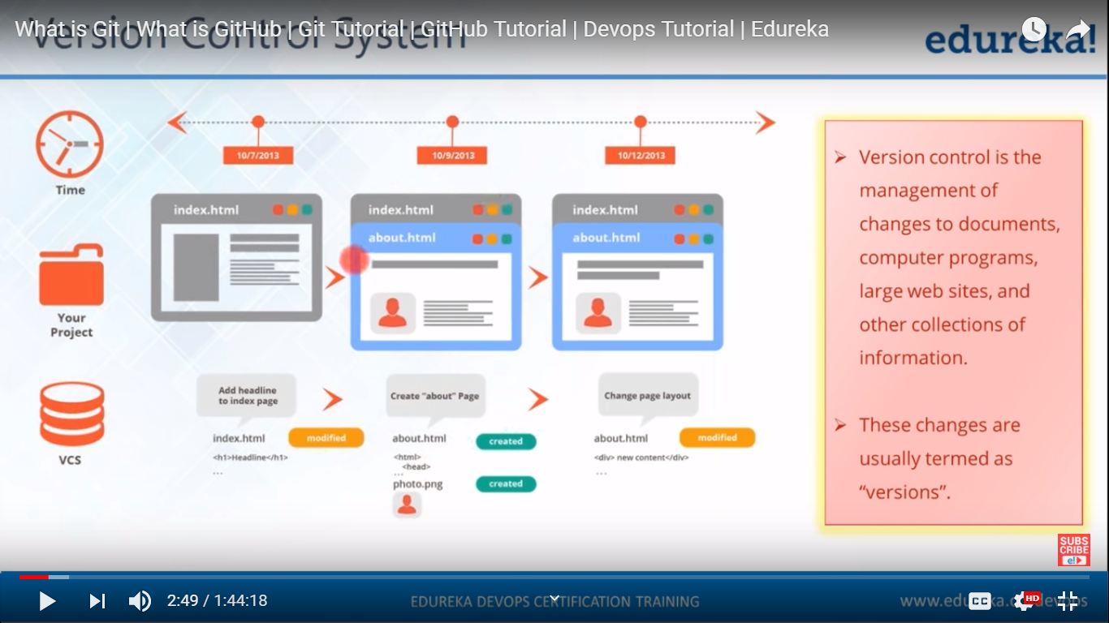

**Why Version Control**

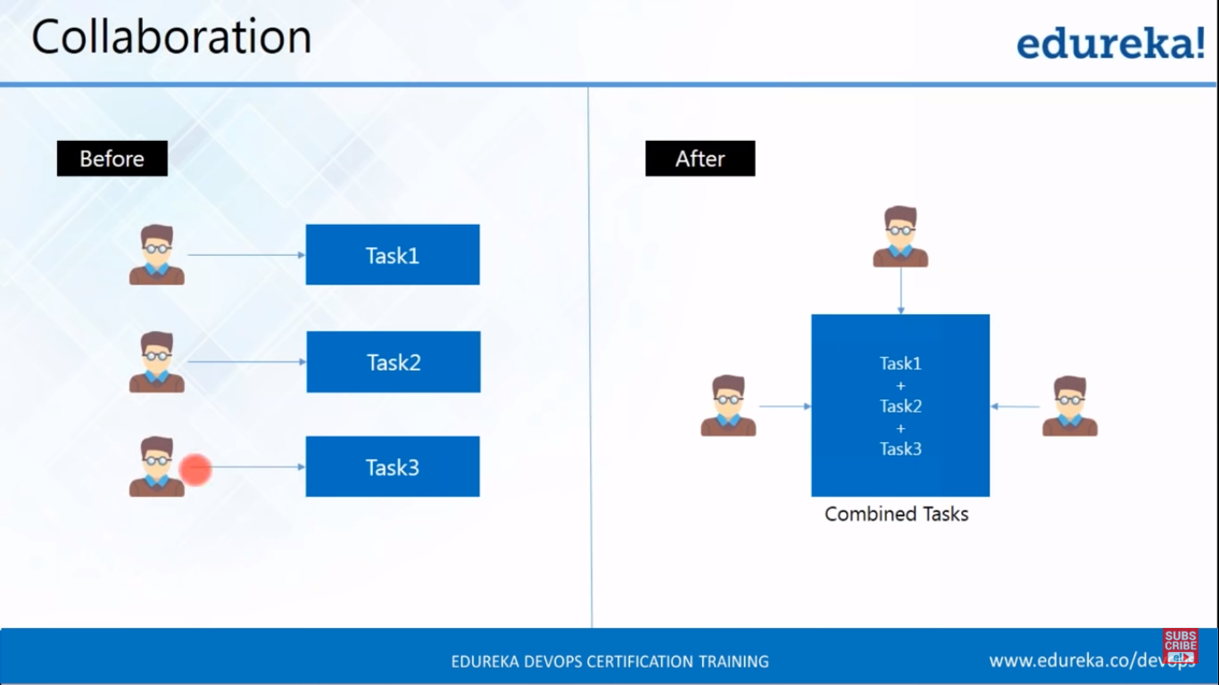

The version control system avails us is **Collaboration.**

Suppose that there are 3 developers working on isolation, means everyone working on his own local repo.

They may work on same file in separate branch, but when they try to merge the code it creates the conflict as the 3 developers have worked on same file.

But with version control system they can know who has made what kind of changes.

**Storing Versions**

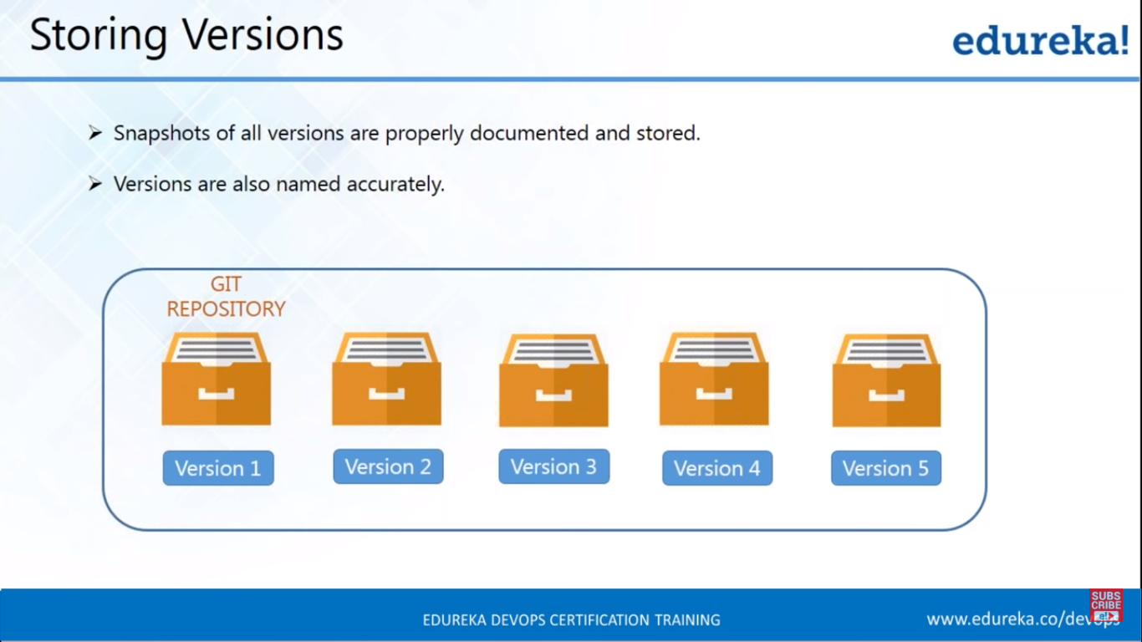

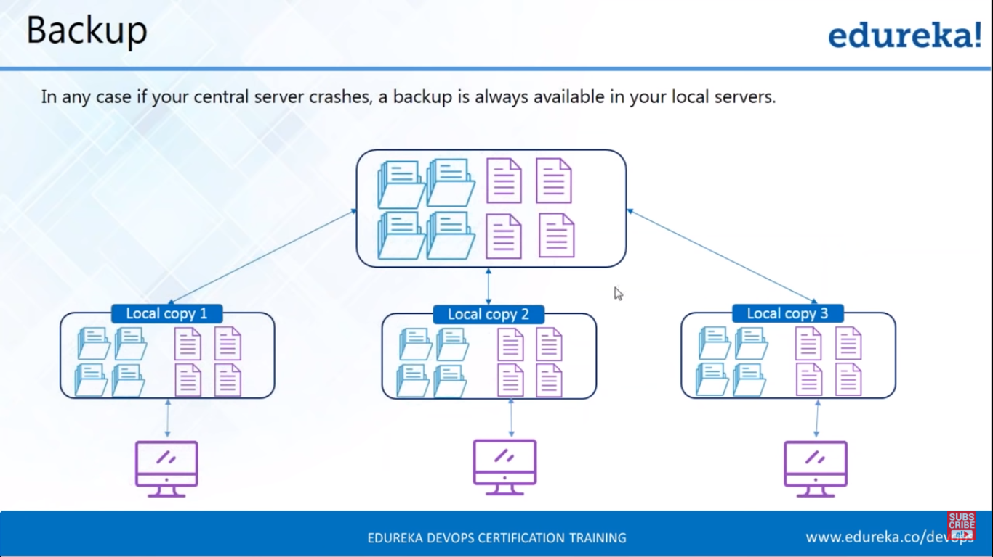

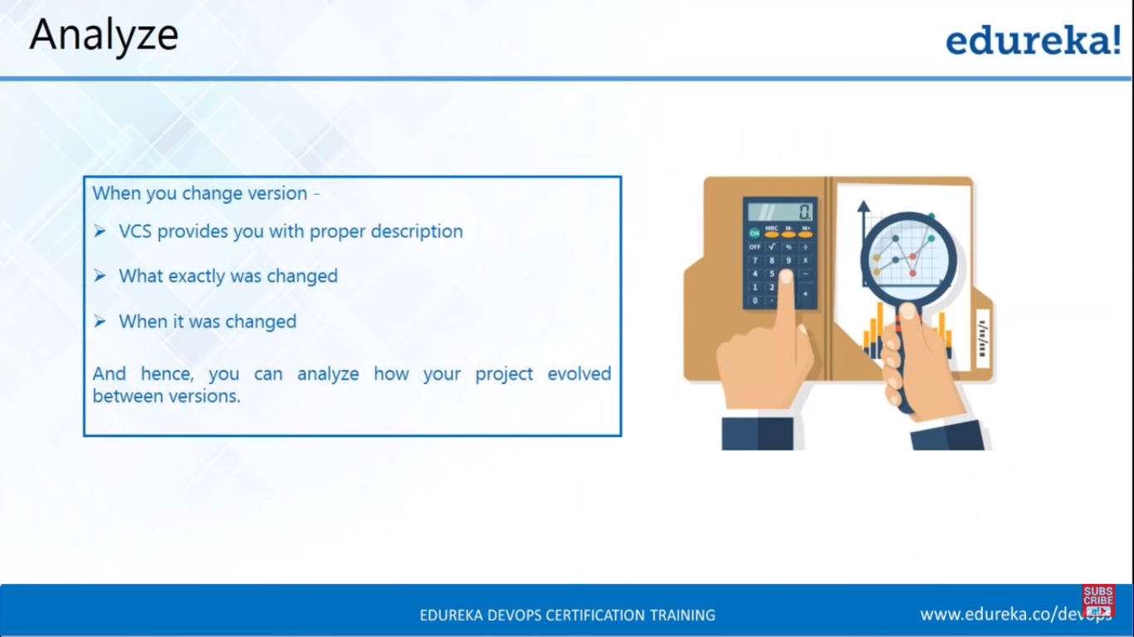

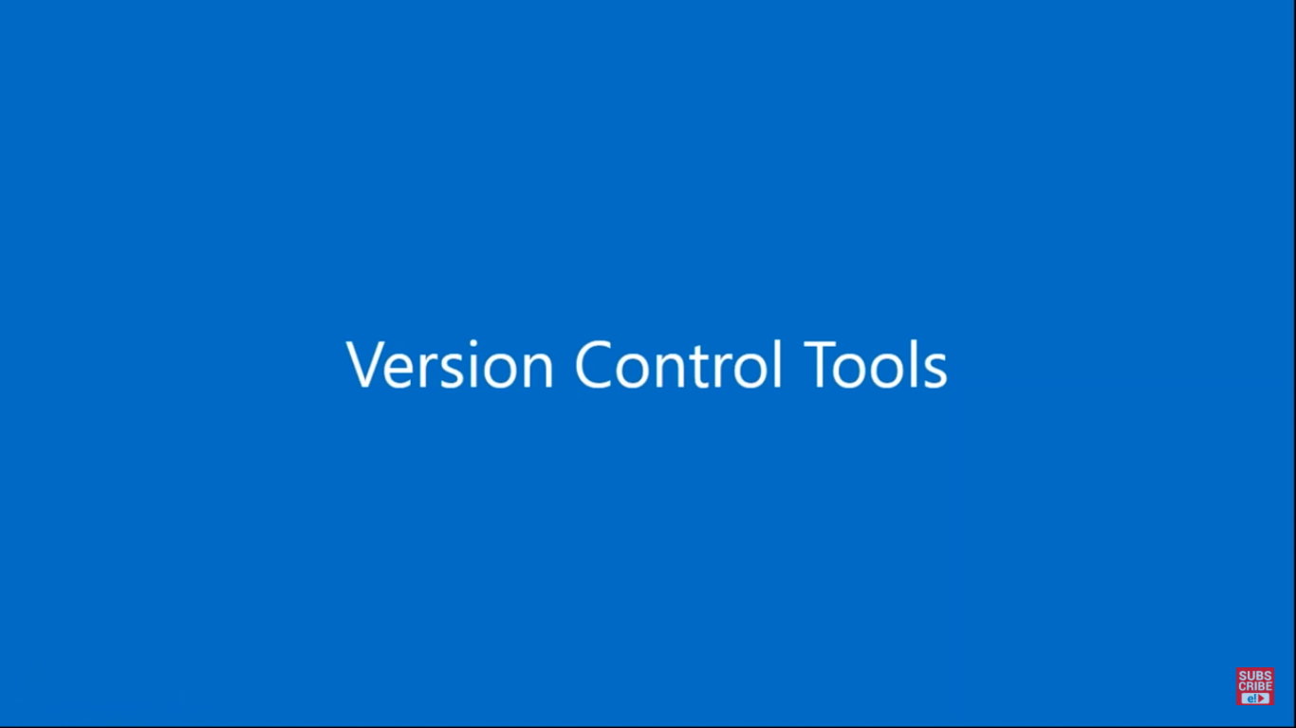

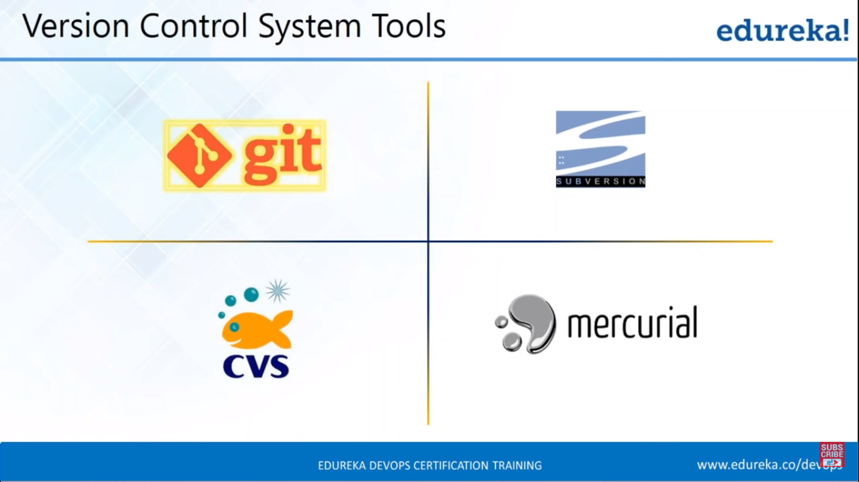

The SubVersion and CVS version control systems don’t provide local copy of repo. The developer works directly with centralised version control system.

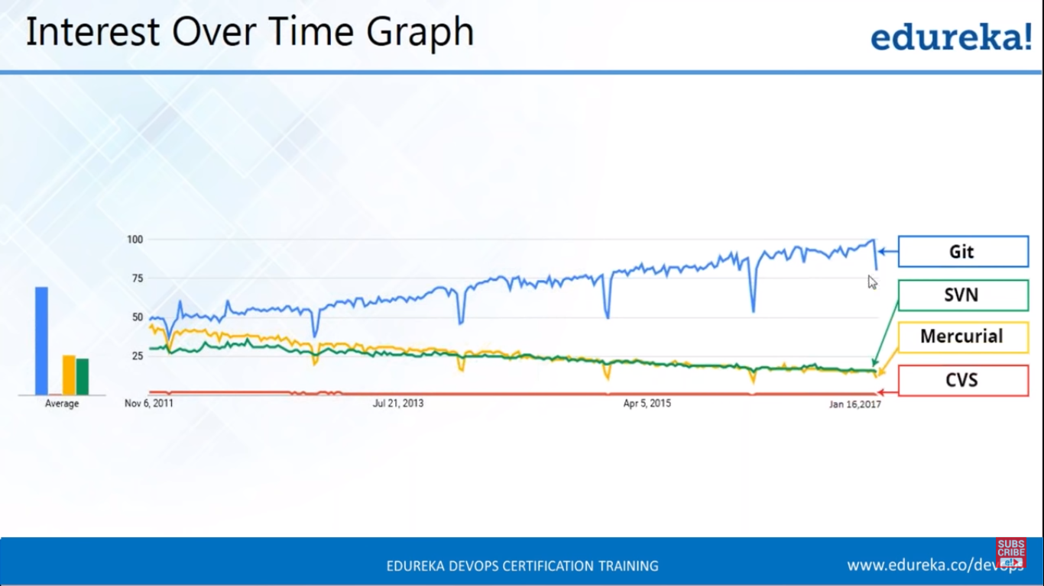

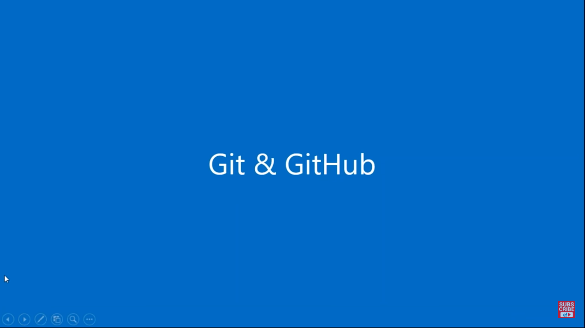

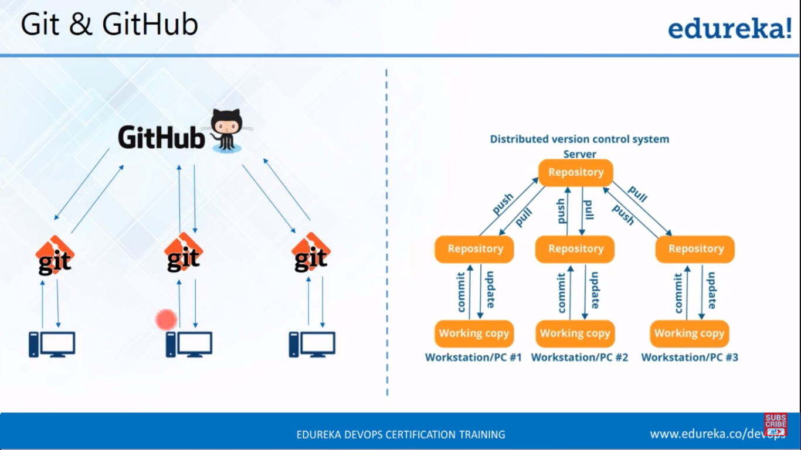

In a distributed version control system, you got a central and local repository and working copy of each developer.

The developer works in working copy and commits the changes to local repo which is isolated to that particular developer. When he confirms that all the changes are fine, he push the code to central repo.

Any developer can pull the latest code from central repo by pull command to his local repo and start working from his working copy.

GitHub is going to be a central repository and git is a tool that is going to allow me to create a local repository.

Git is version control tools which allow you to perform all the kind of operations to fetch the data from the central server and push all your local files to the central server.git is a version control management tool.

GitHub is a code hosting platform for the version control system.

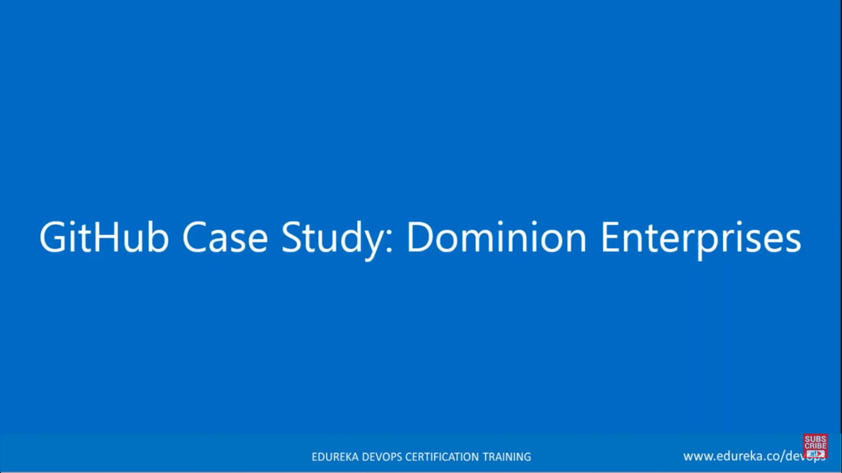

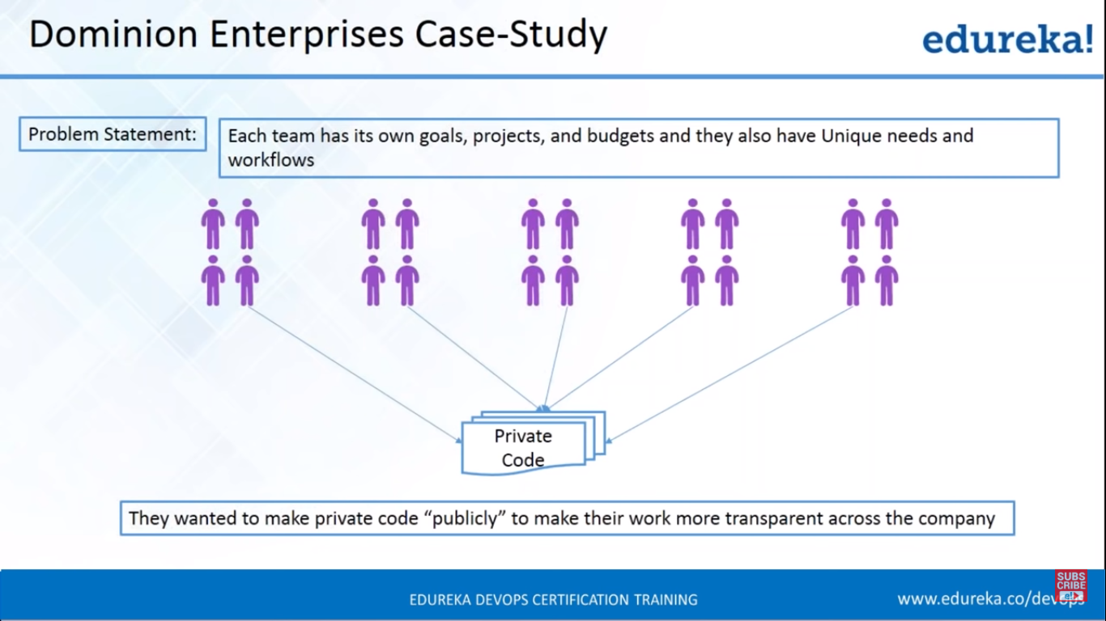

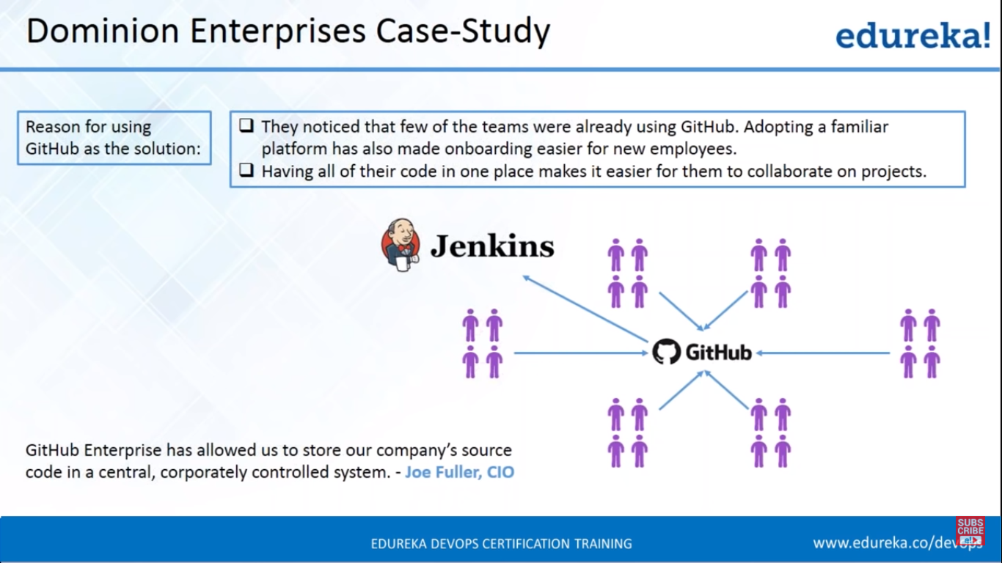

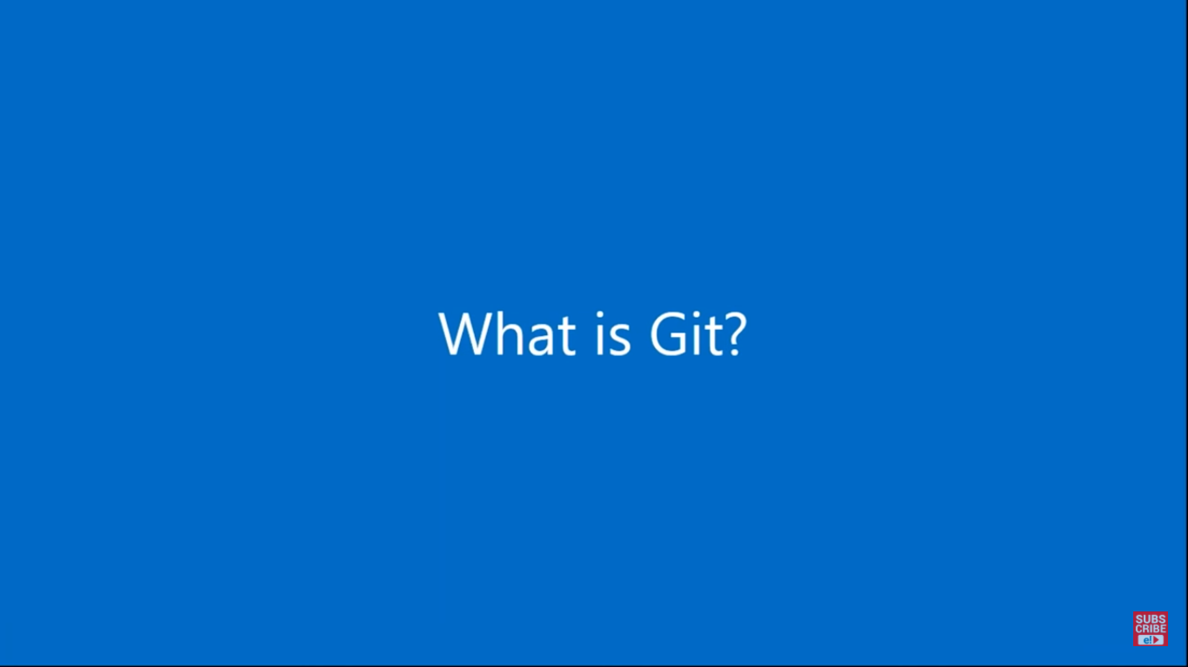

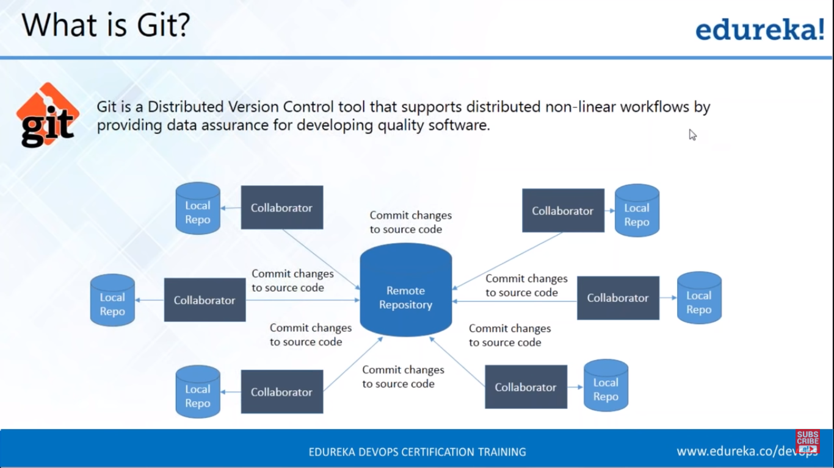

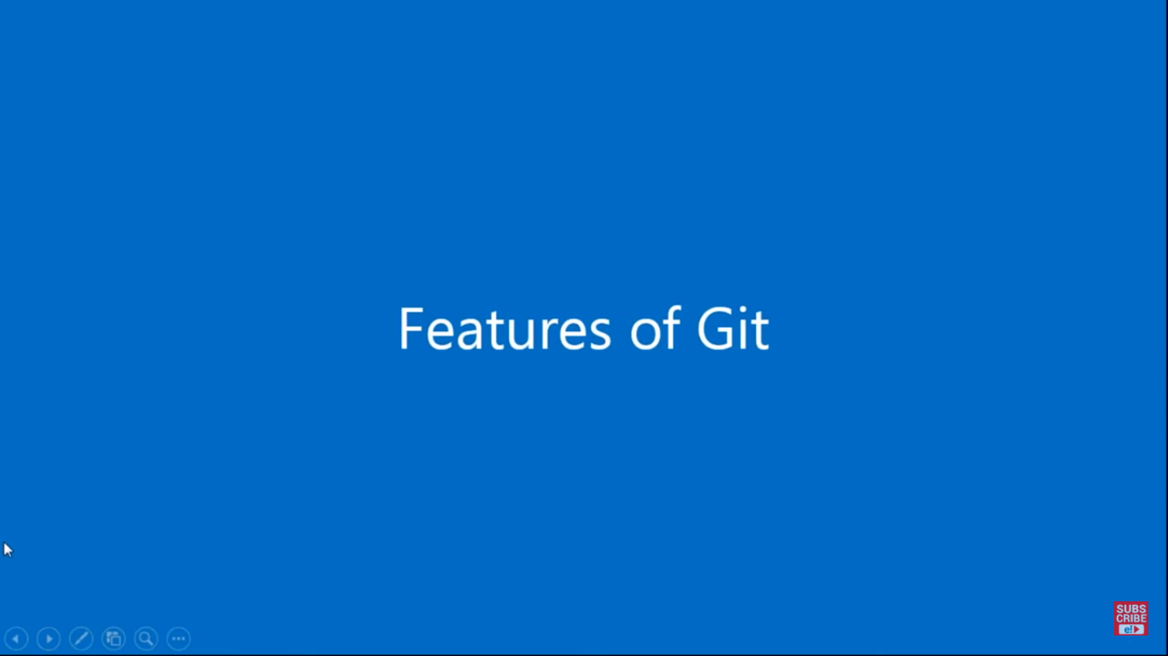

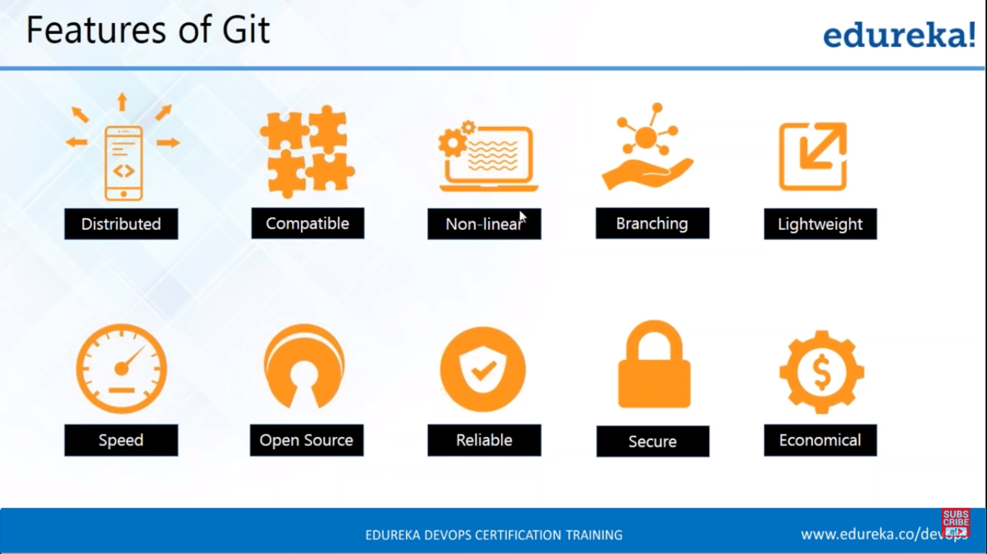

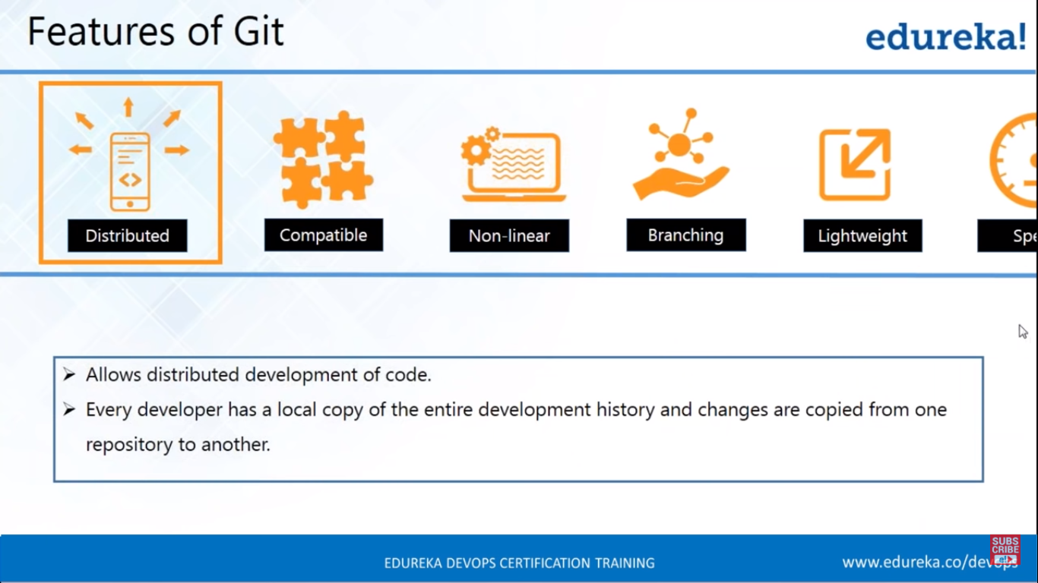

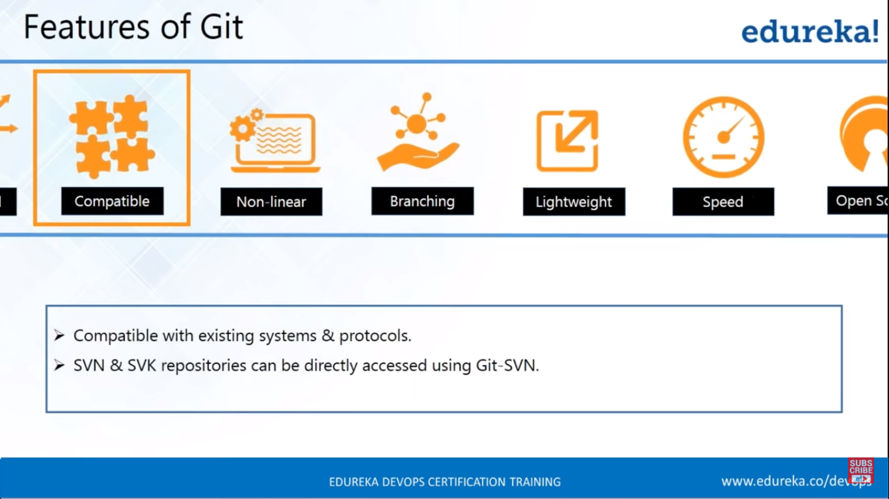

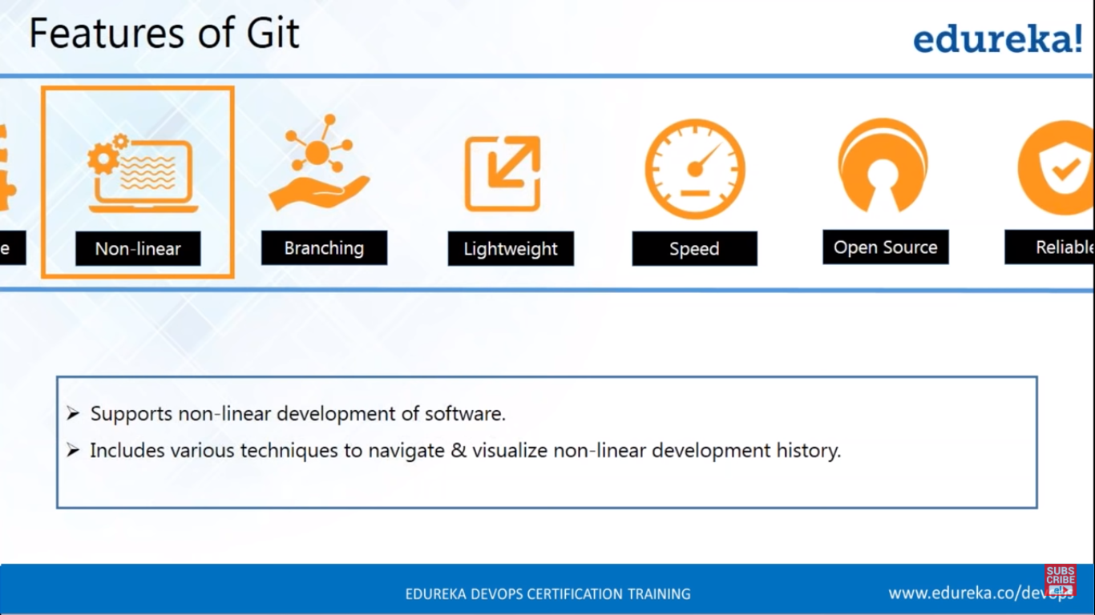

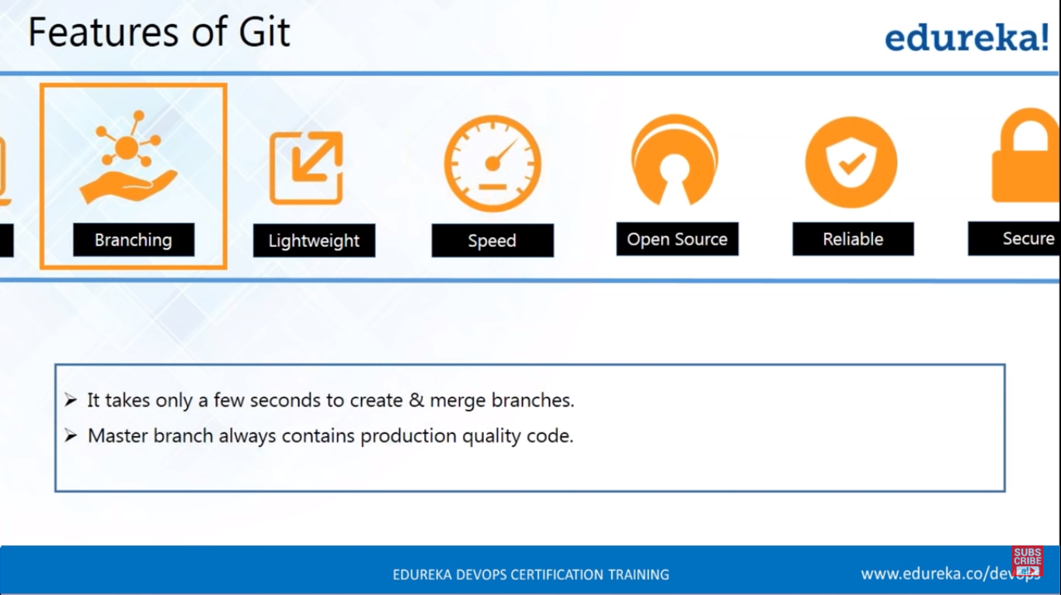

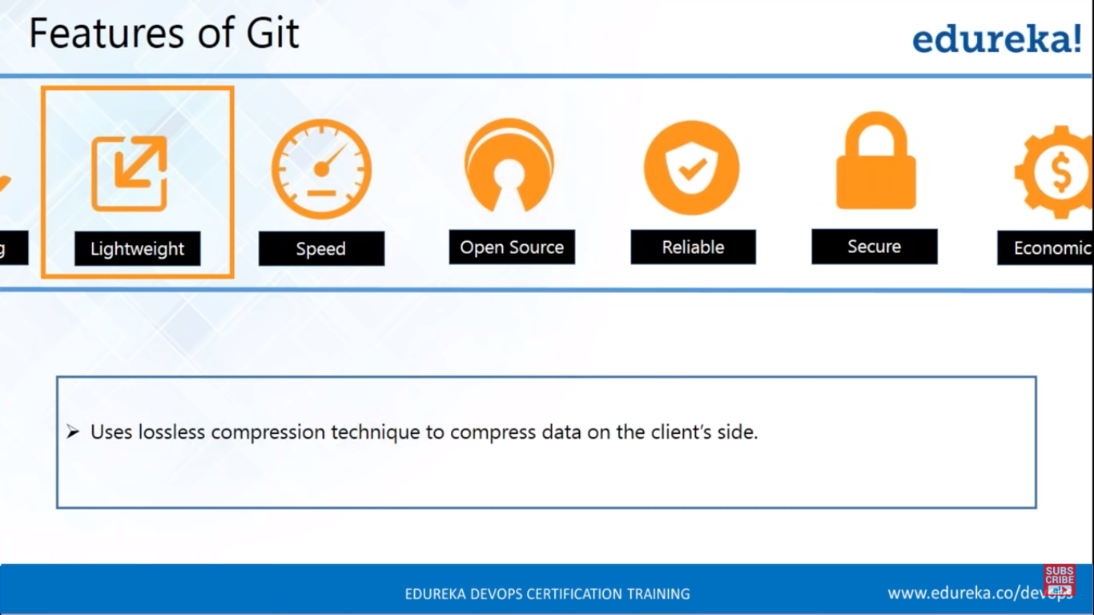

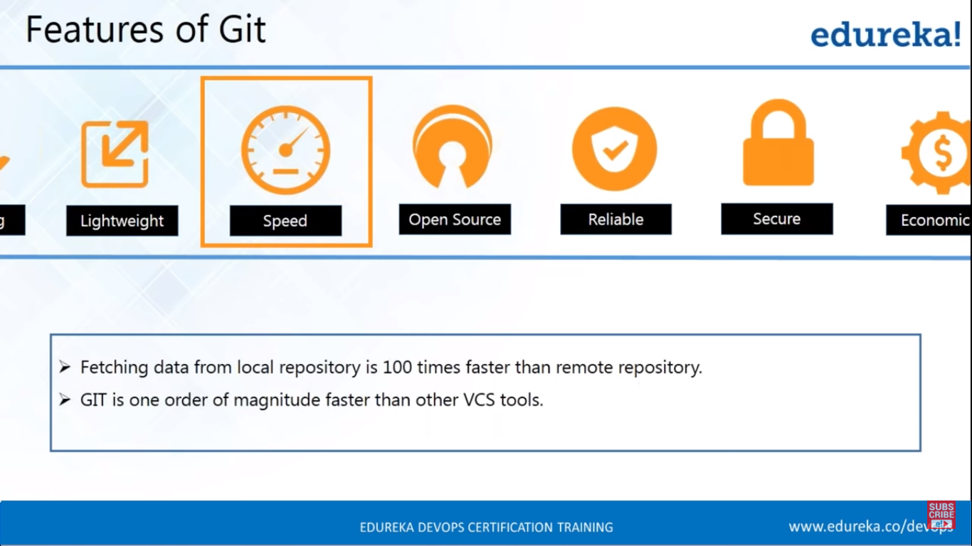

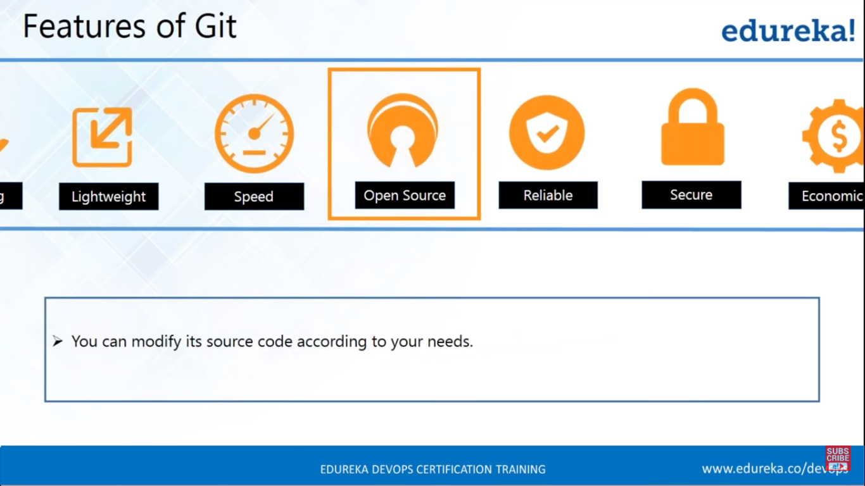

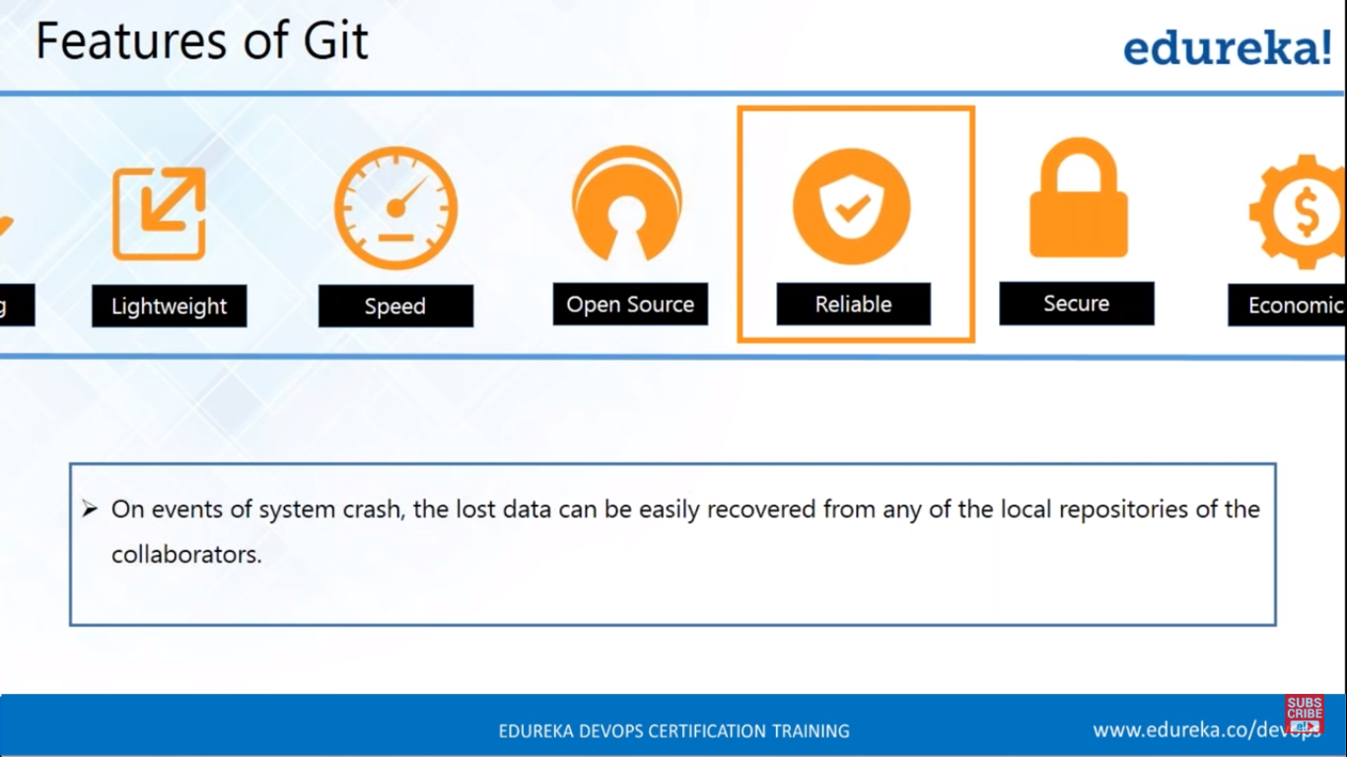

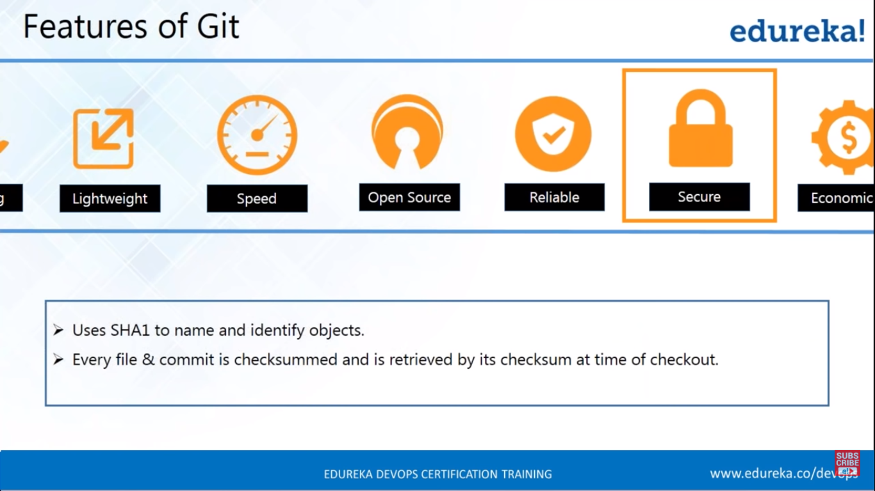

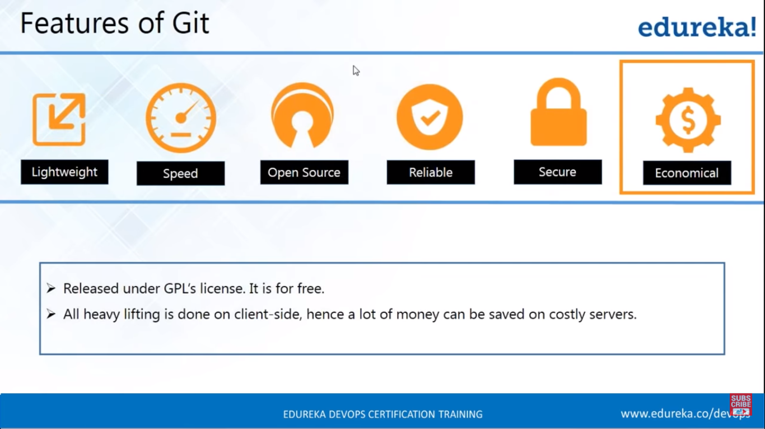

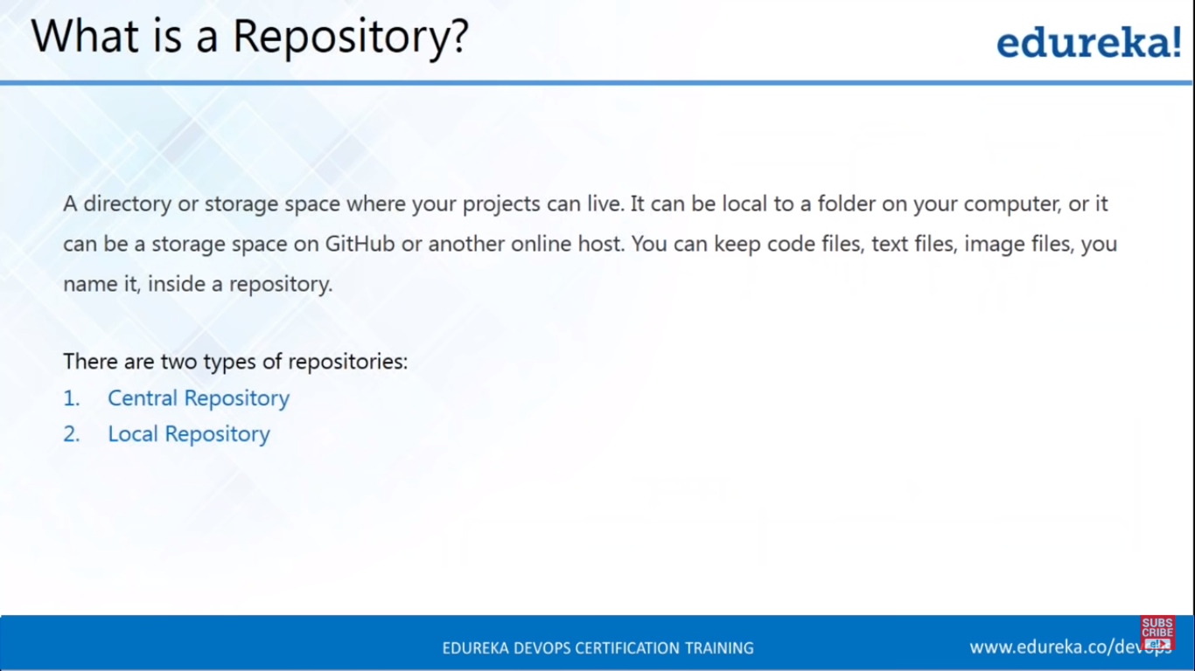

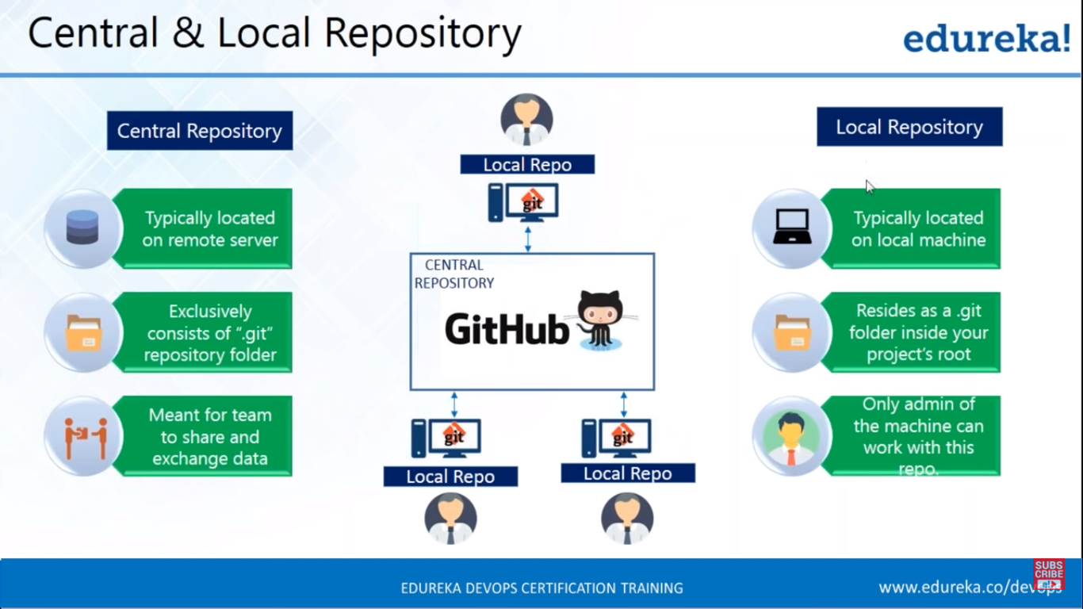

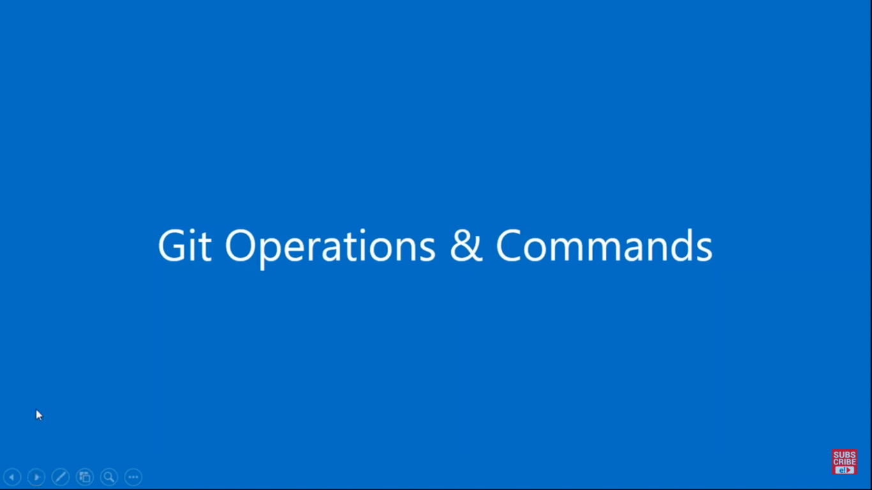

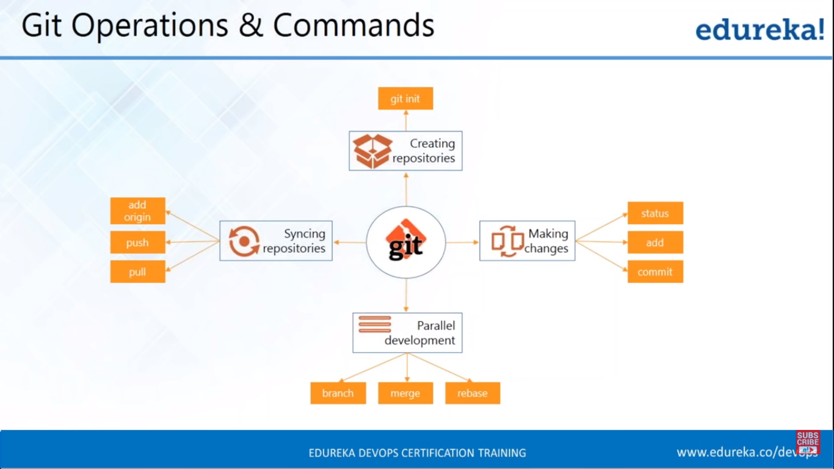

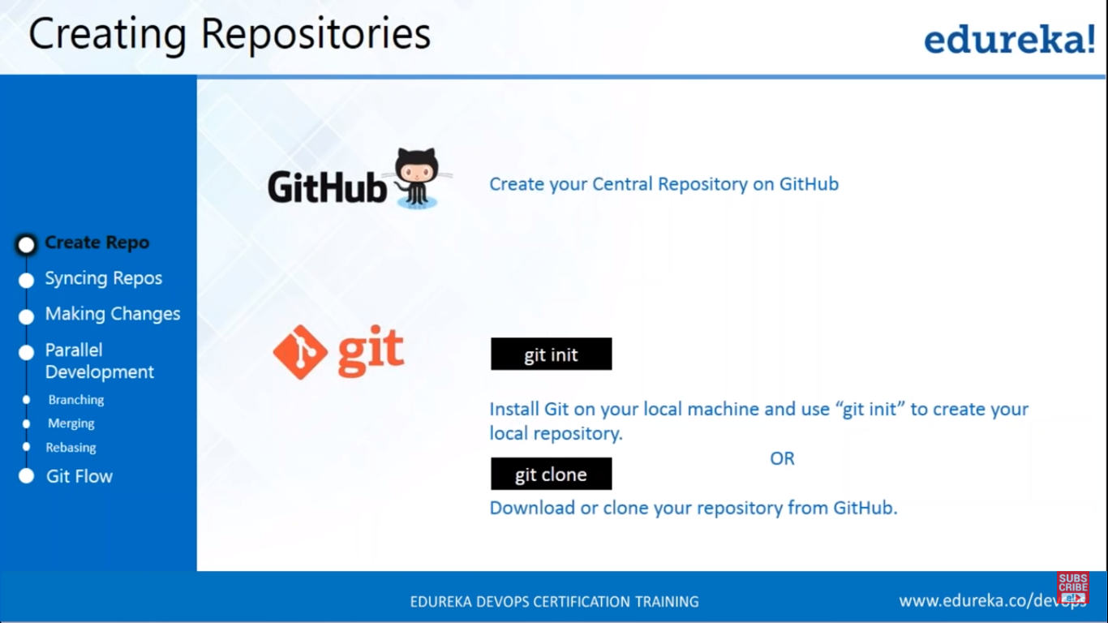

**GitHub credentials**

Username: [tandrarajesh28@gmail.com](mailto:tandrarajesh28@gmail.com)

Password: Pallavi@36

Git commands

git init

git remote add origin "https://github.com/tandrarajesh/Documents.git"

git pull origin master

git status

git add "<file name>"

git commit -m "<comment>"

git push <repo name> <branch name>

git push https://github.com/tandrarajesh/Documents.git origin

git push origin master

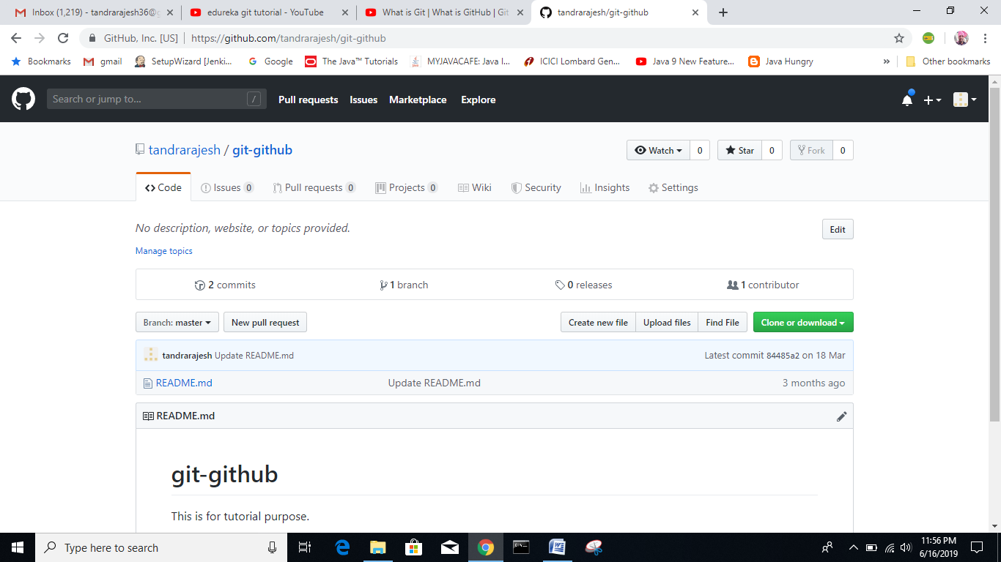

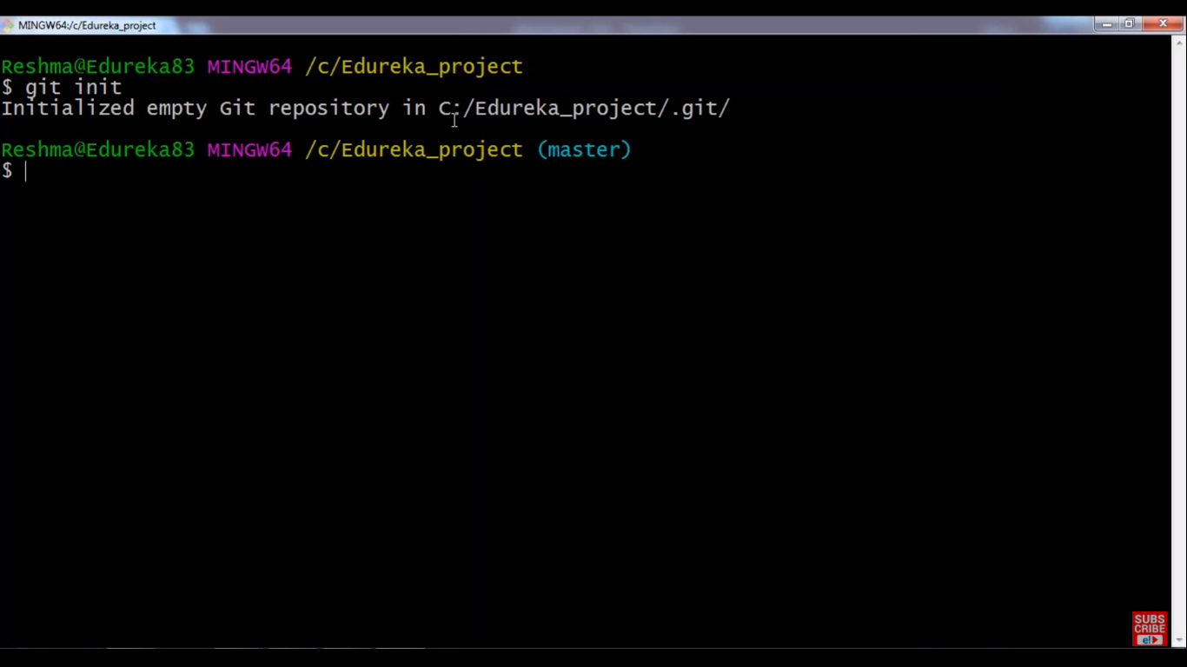

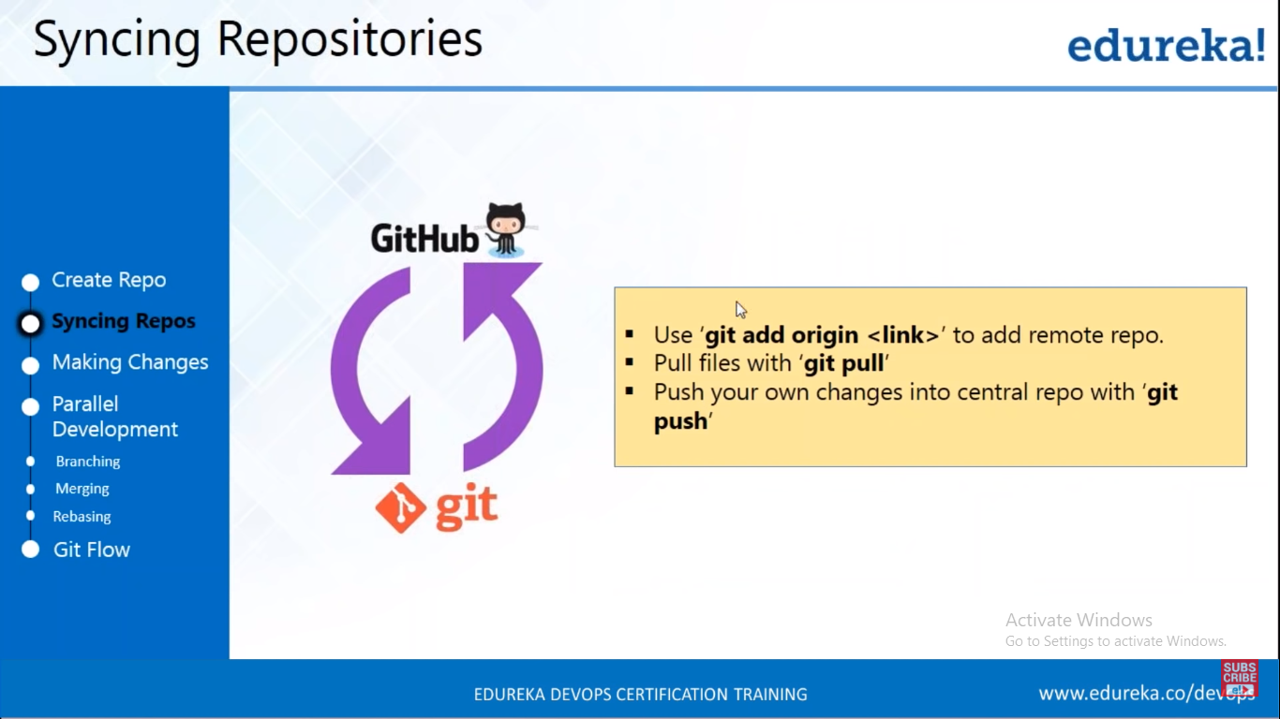

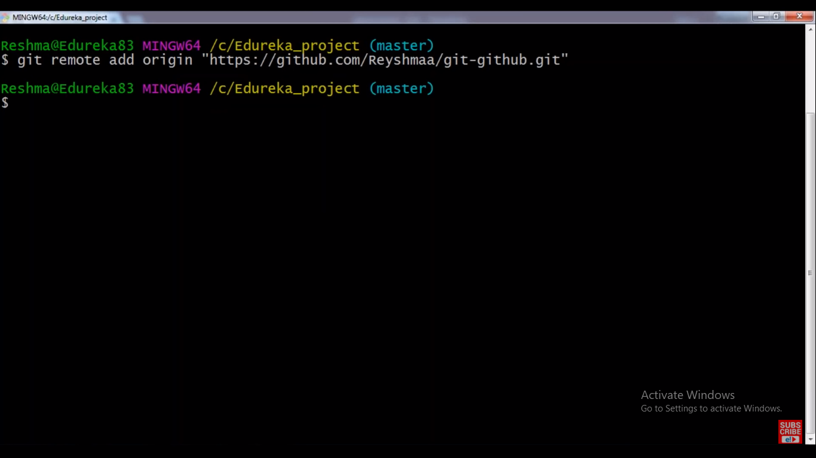

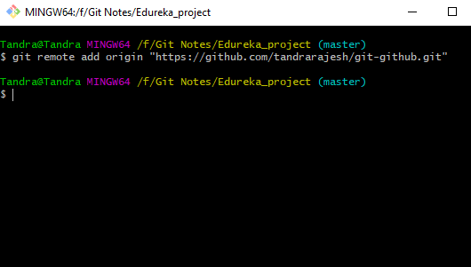

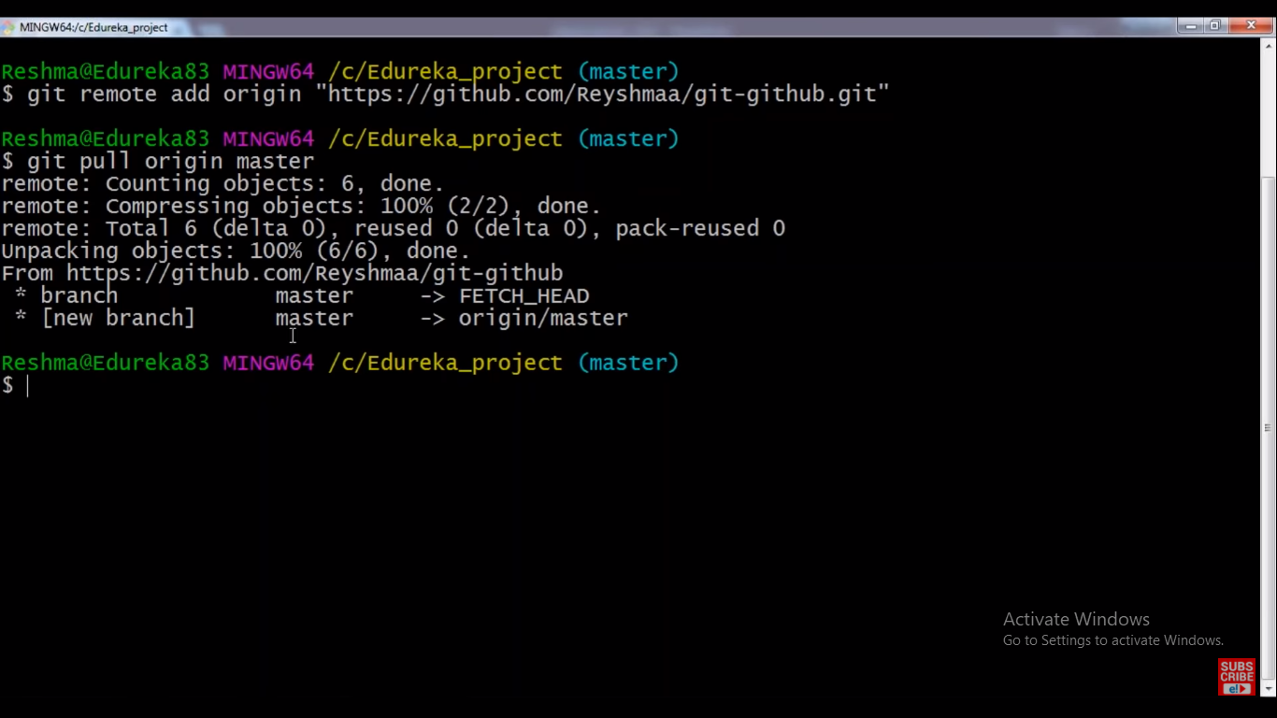

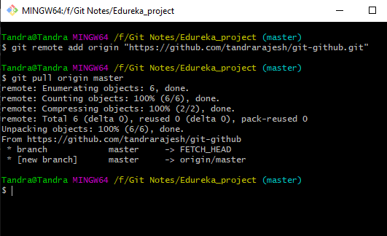

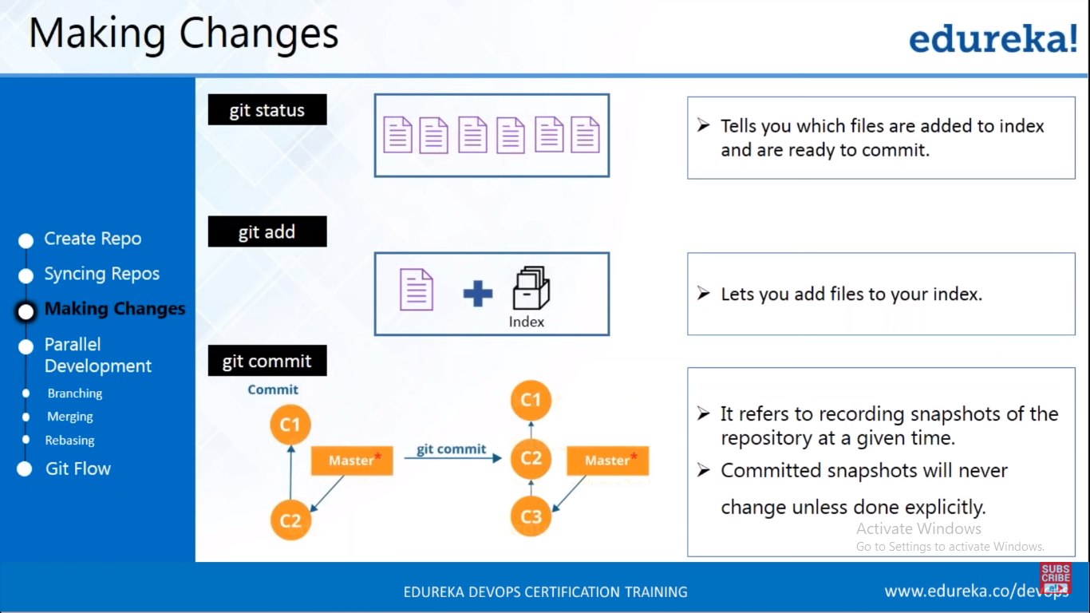

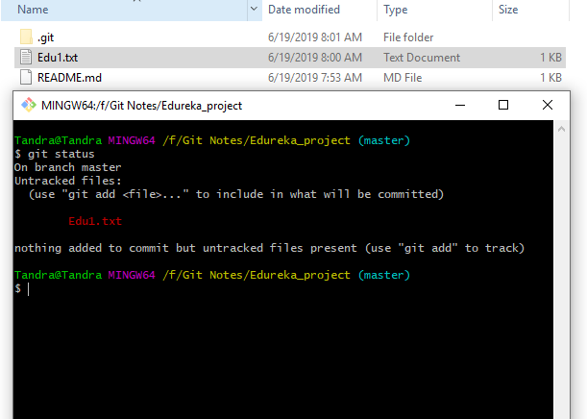

To get the status of files which are added to index and committed, give the following command.

**Git status**

To add the files into index, give the following command.

**Syntax**

Git add %File_name%

Git add Edu1.txt

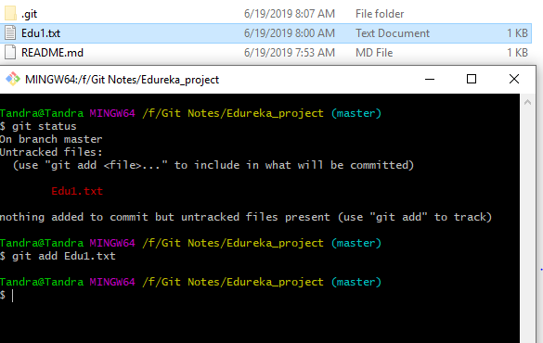

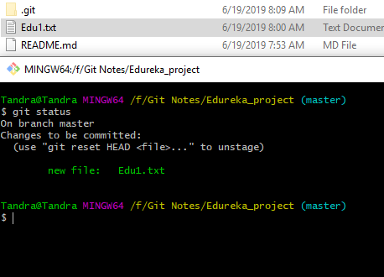

The following is the error message when you are not authenticated.

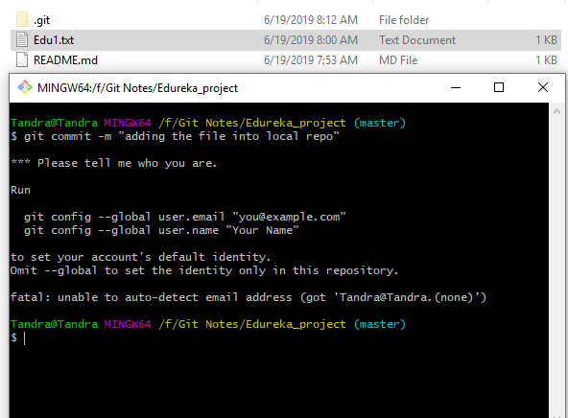

To get authenticated with your email, give the command

$ git config --global user.email "you@example.com"

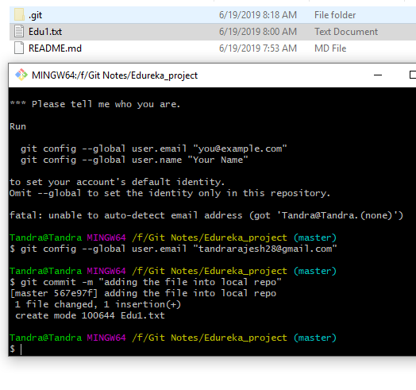

Commit message will be displayed successfully.

After changing the existing files and adding the new files.

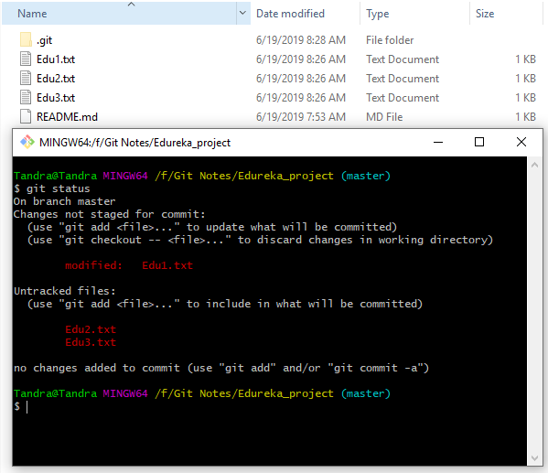

To add the files to index.

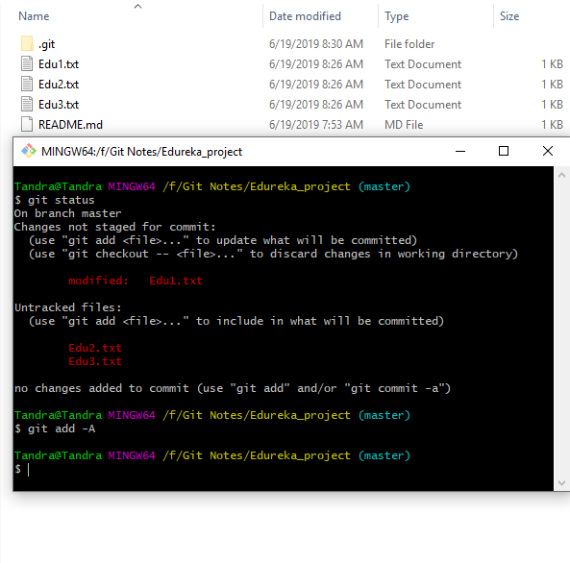

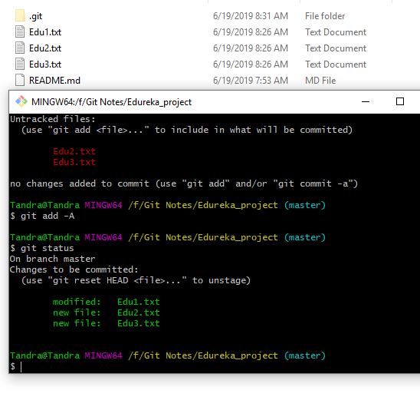

To commit all the changes which added to index.

The following is the command.

git commit –a –m “message”

